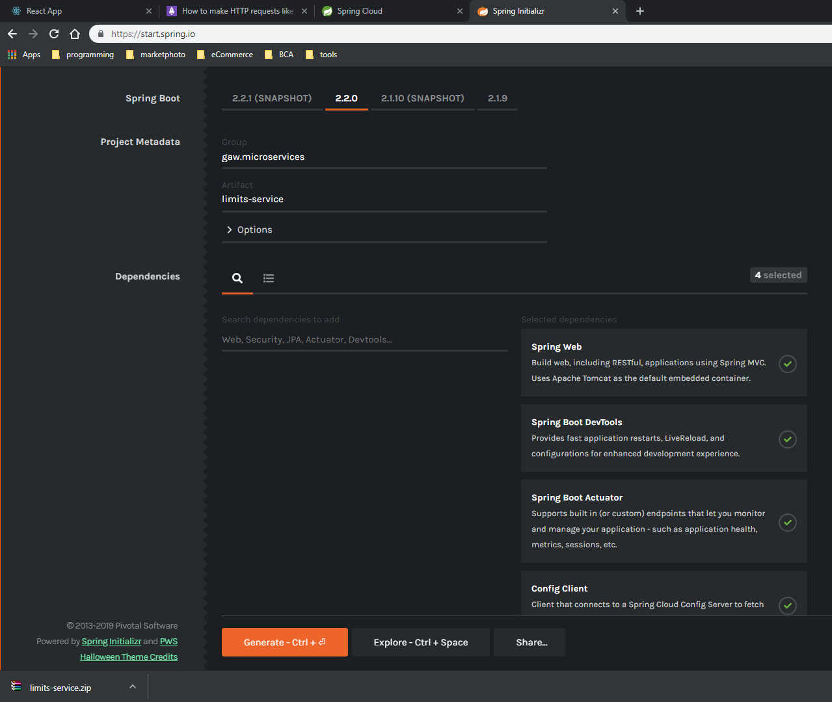

pom.xml:

* Tambahkan maven version di properties

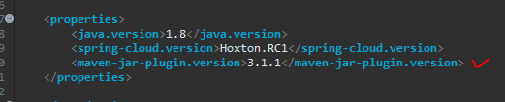

* Tambahkan version pada dependency spring-cloud-starter-config

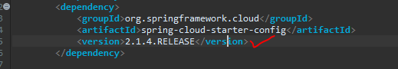

* disable/hapus dependency management & repositories (karena dalam config kantor)

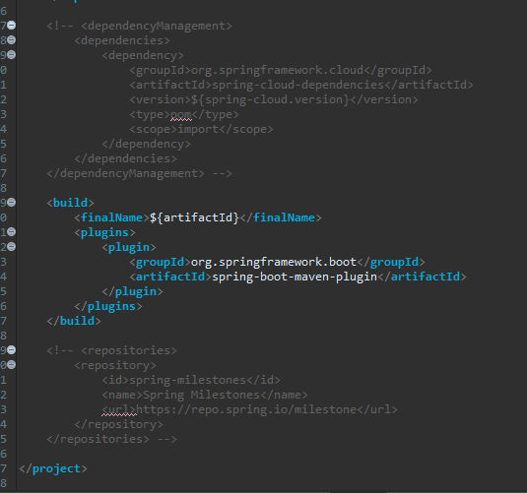

Create hard coded limits service

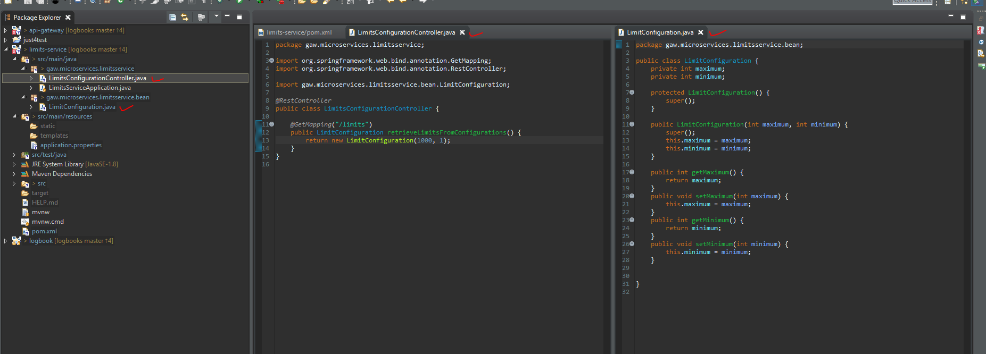

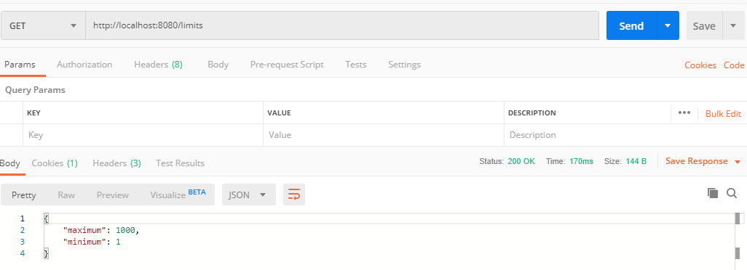

enhance limits service to get configuration from application.properties

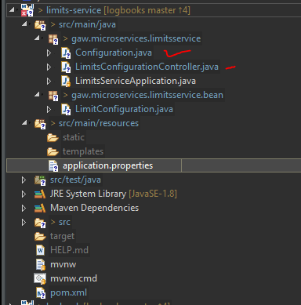

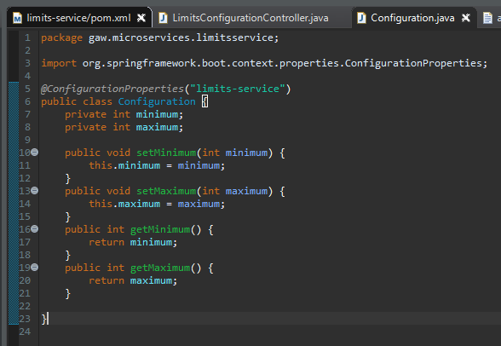

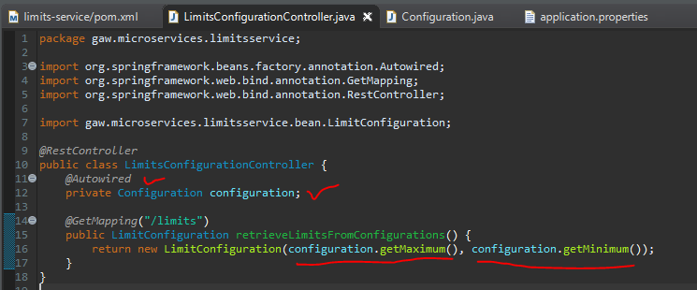

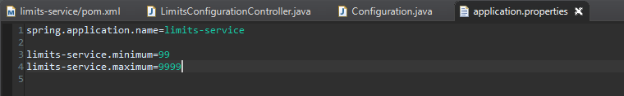

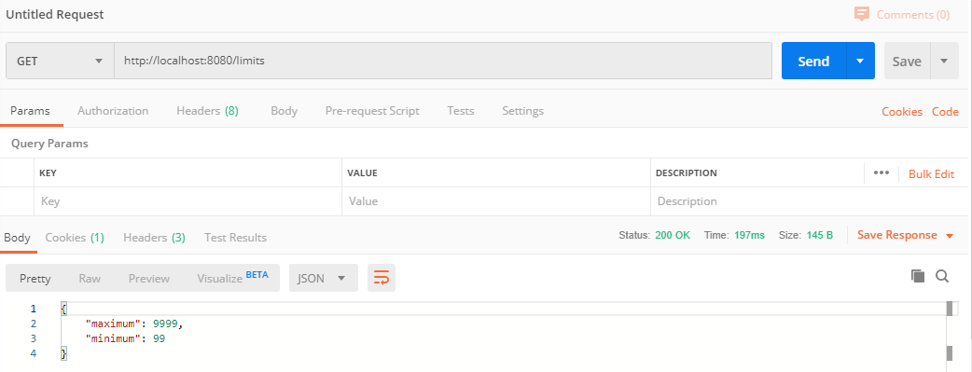

==============================================================================================

Setting up spring cloud config server

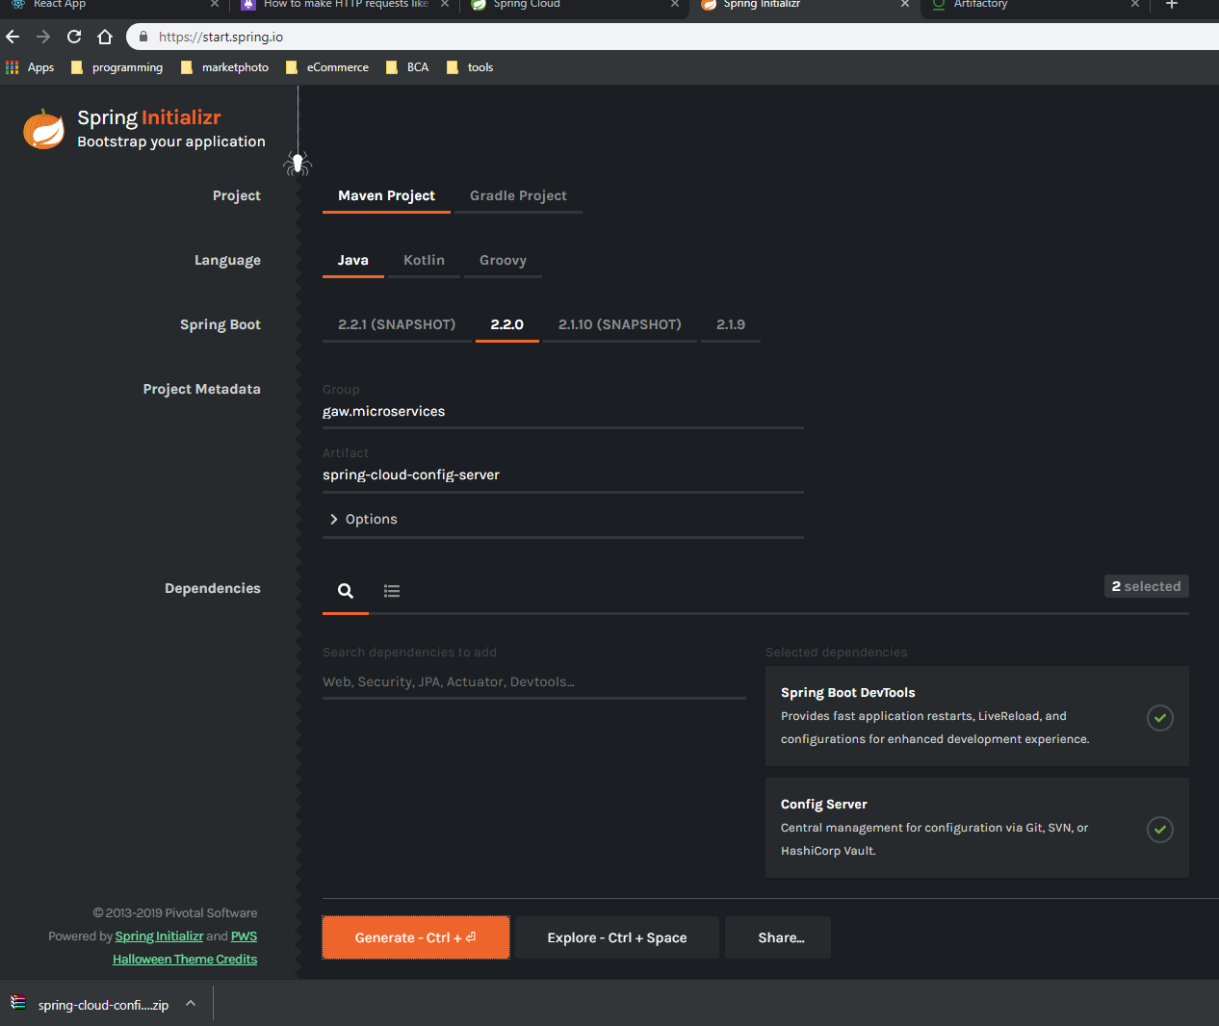

Config pom.xml sama seperti limits-service

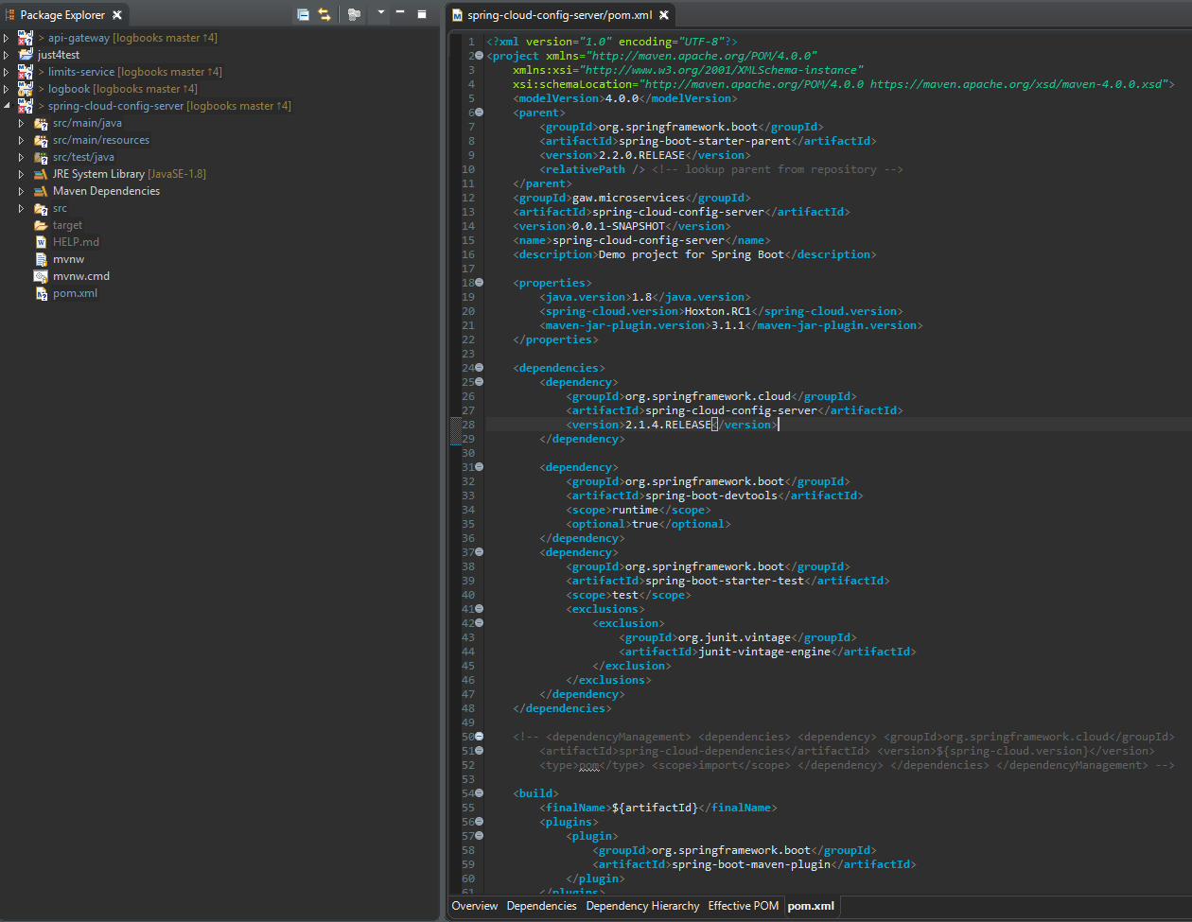

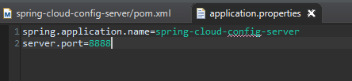

mikin git-repo ‘git-localconfig-repo’

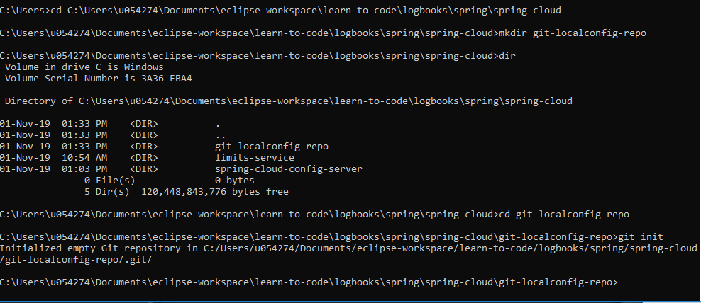

Balik ke eclipse > spring-cloud-config-server, klik kanan>Build Path>Link Source

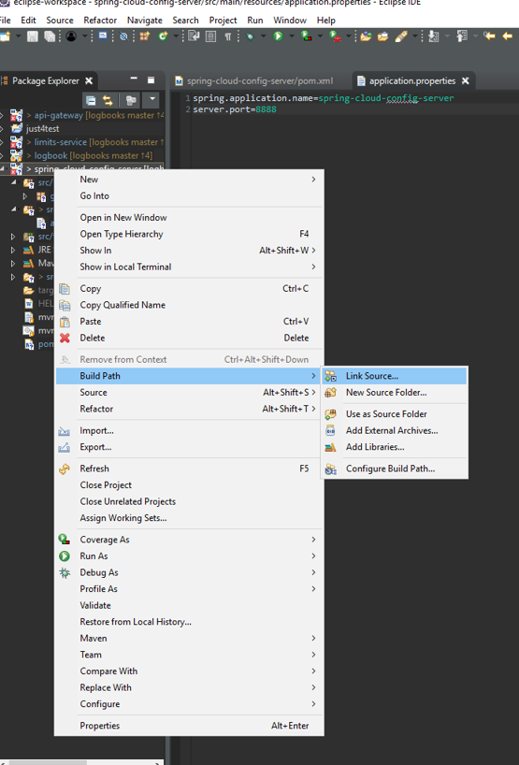

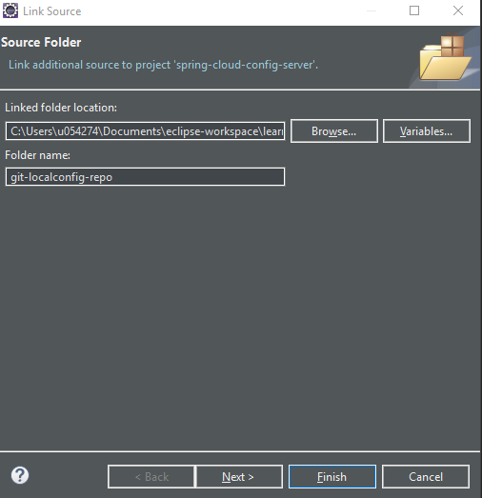

Create file ‘limits-service.properties’, lalu copy parameter dari limits-service yang telah dibuat

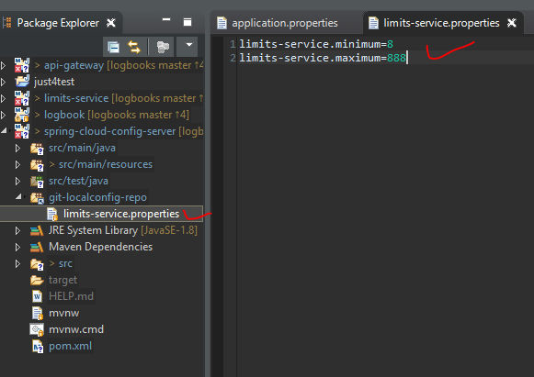

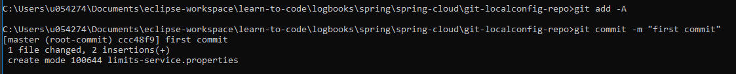

**Connect Spring Cloud Config Server to Local Git Repository**

Klik kanan pada folder ‘git-localconfig-repo’ > properties

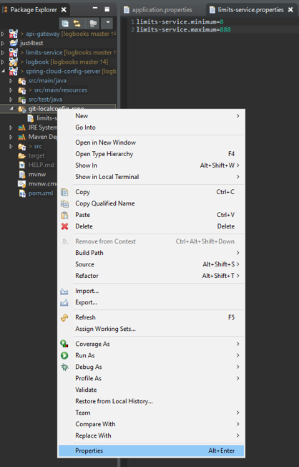

Copy location

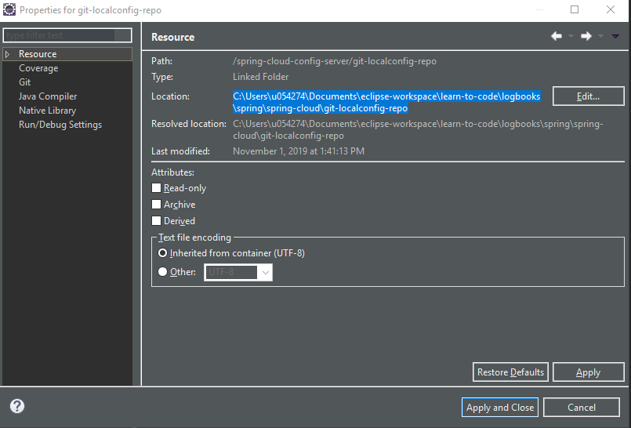

Copy uri-nya ke config application.properties

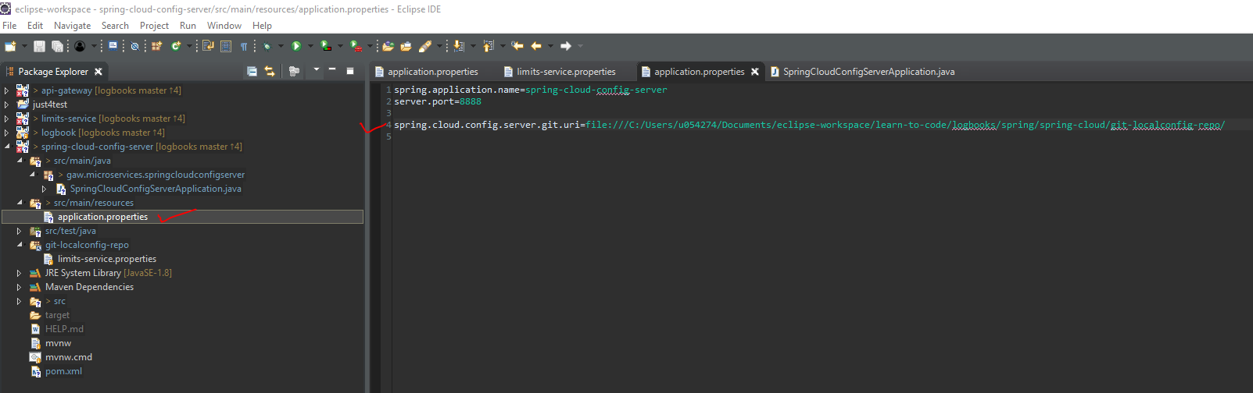

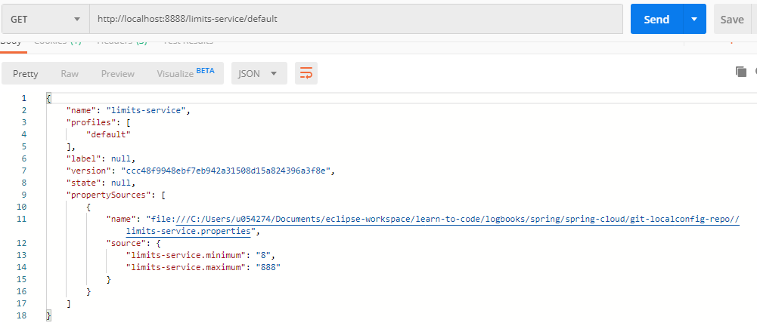

**Configuration for Multiple Environments in Git Repository**

Duplicate file properties

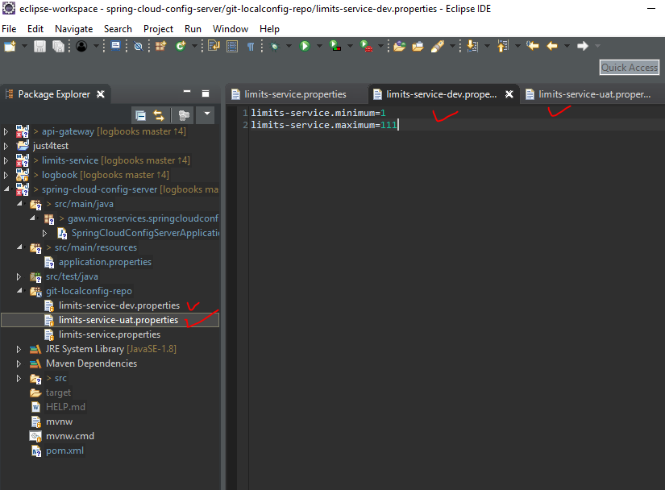

git commit

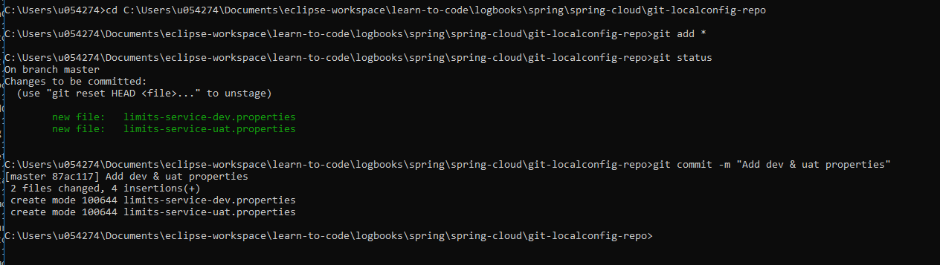

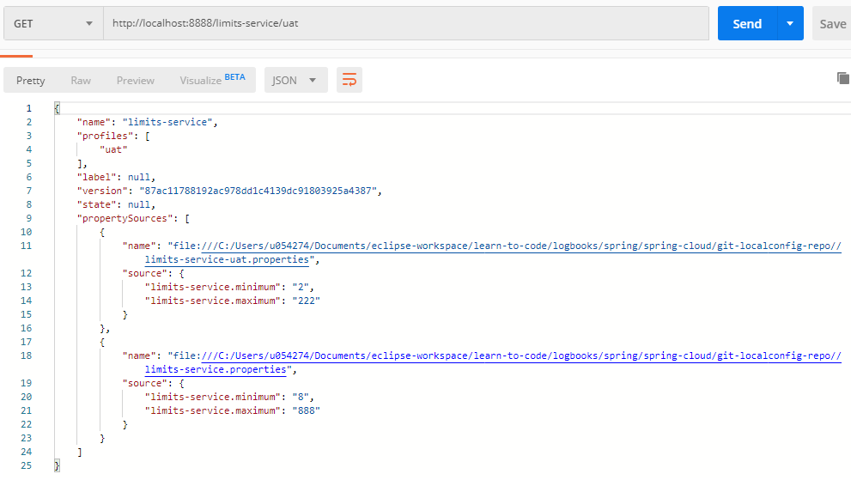

**Connect Limits Service to Spring Cloud Config Server**

rename file ‘application.properties’ 🡪 ‘bootstrap.properties’

hapus config sebelumnya

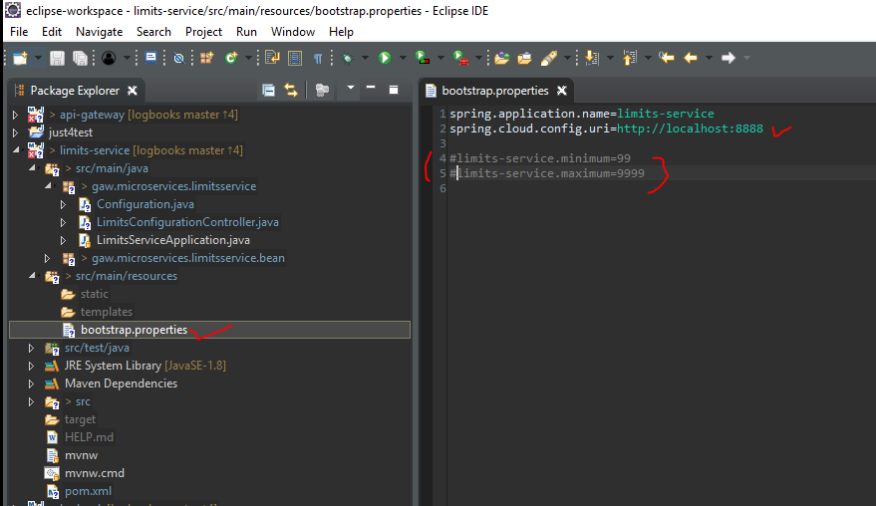

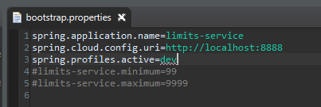

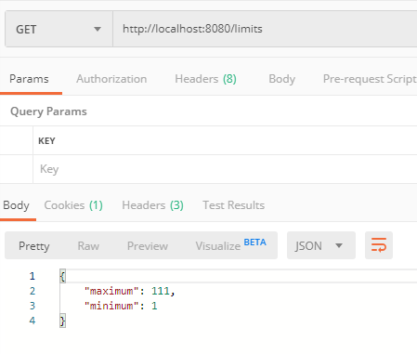

==============================================================================================

Create a simple hard coded currency exchange service

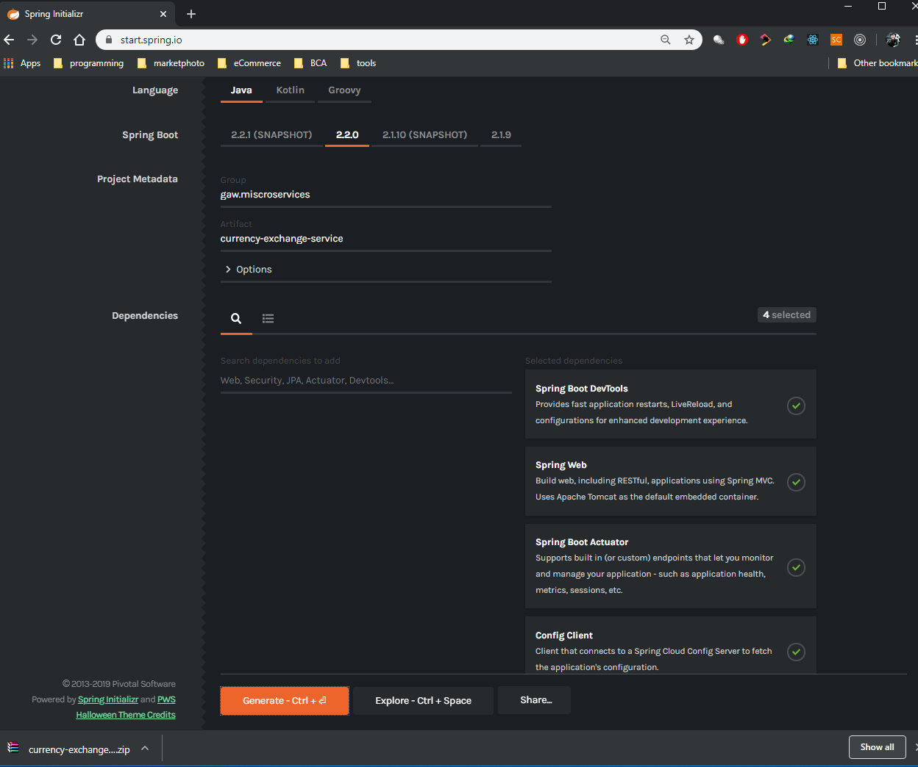

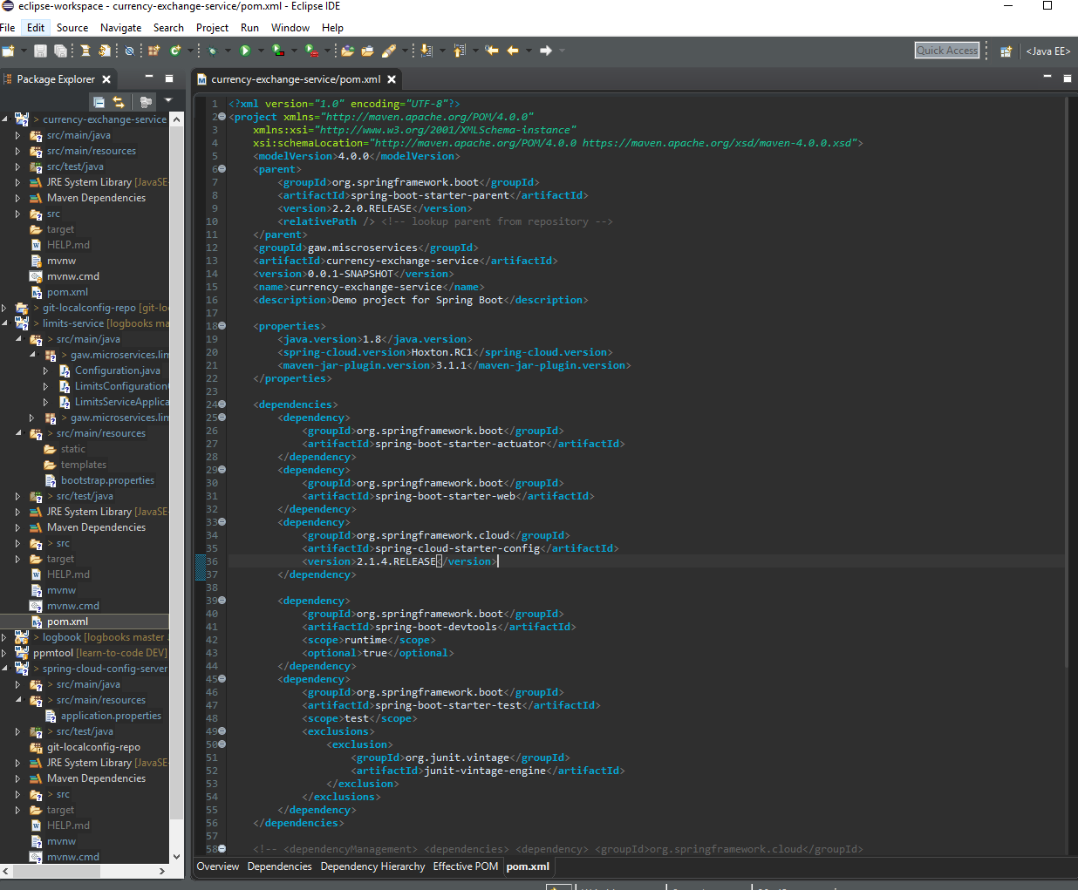

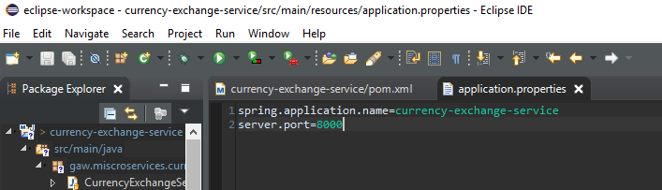

Setting up Dynamic Port in the Response

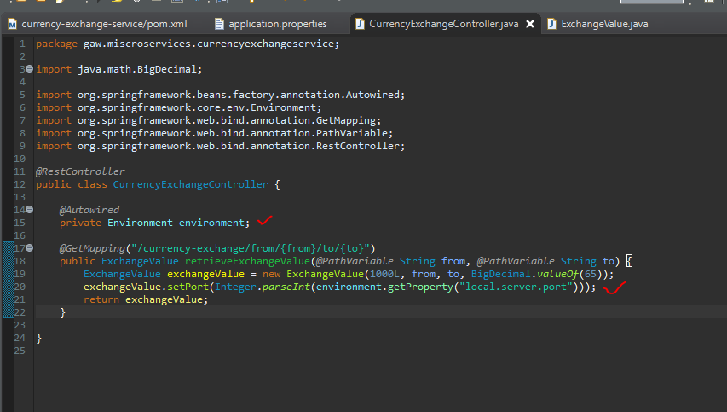

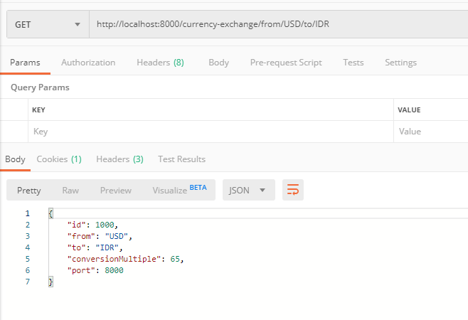

==============================================================================================

Create a currency conversion service

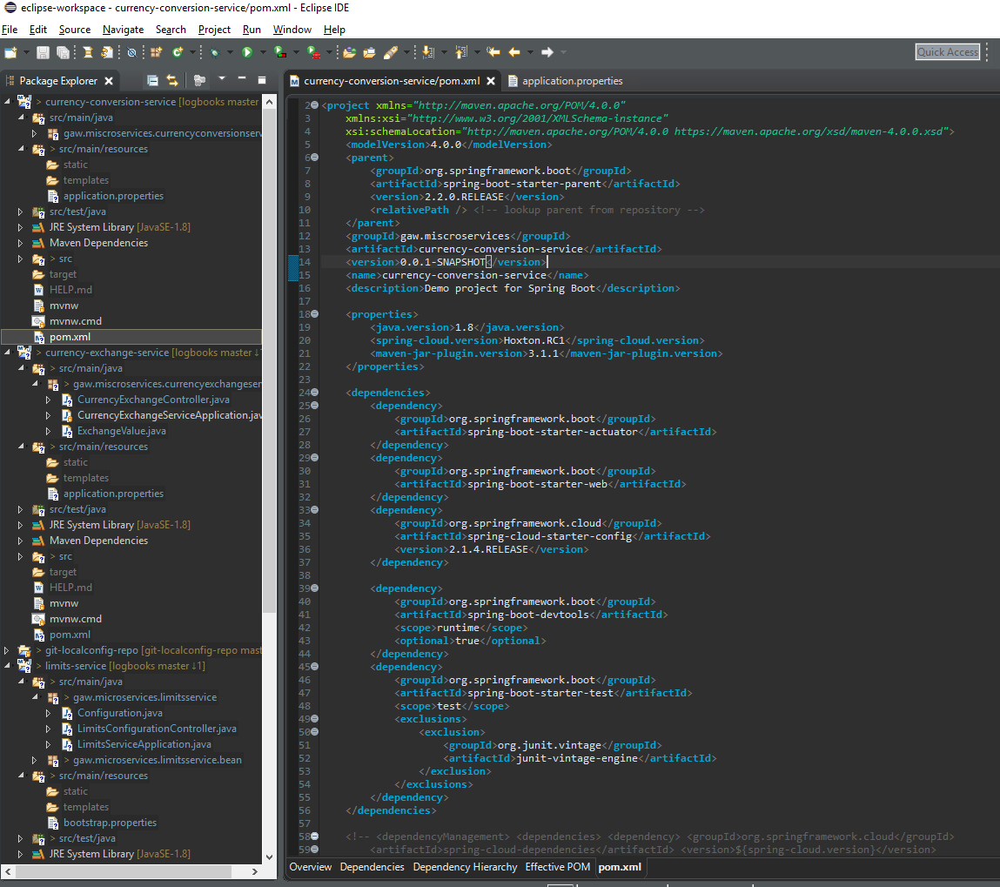

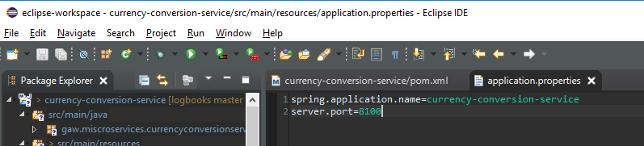

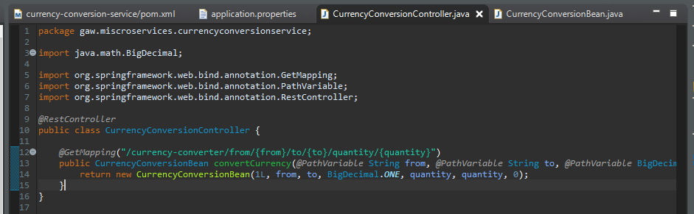

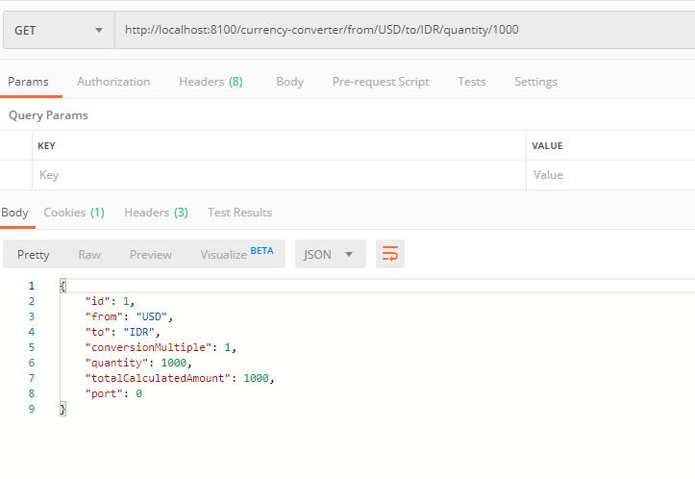

**Invoking Currency Exchange Microservice from Currency Conversion Microservice**

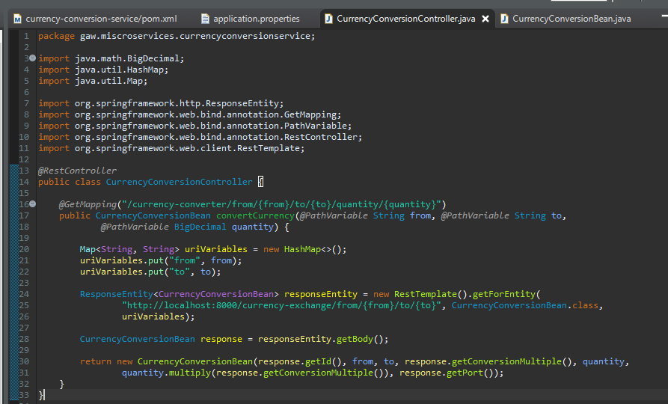

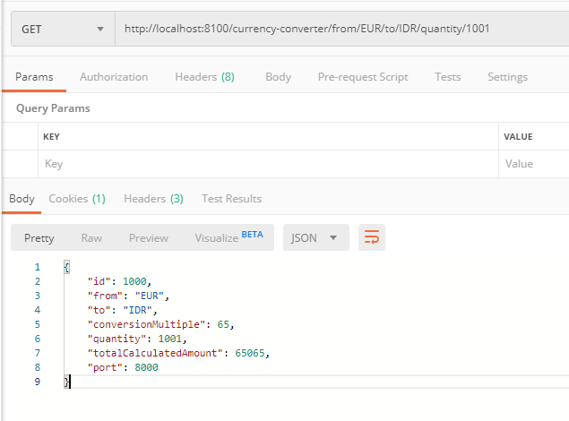

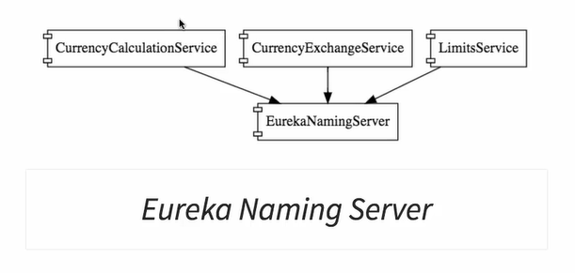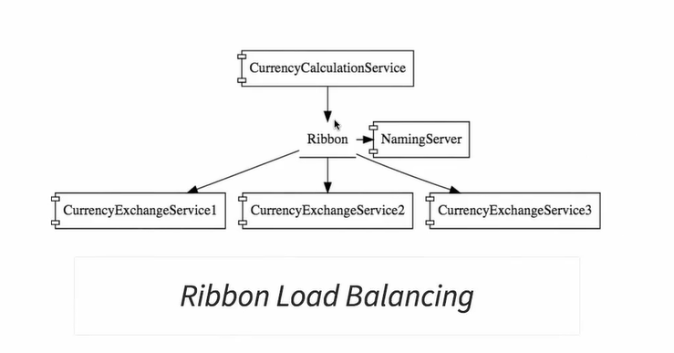

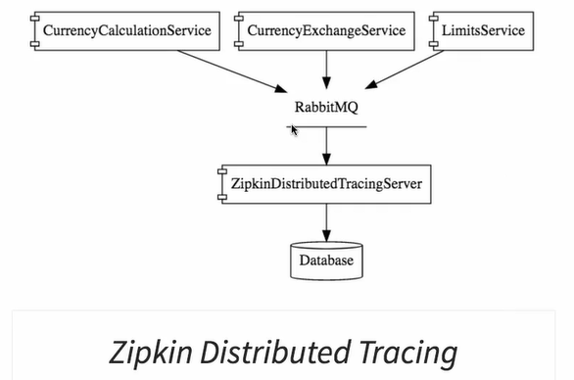

**Using Feign REST Client for Service Invocation**

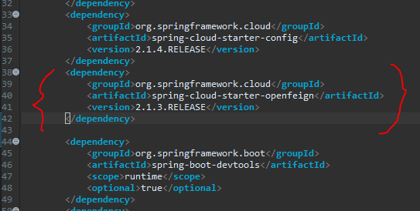

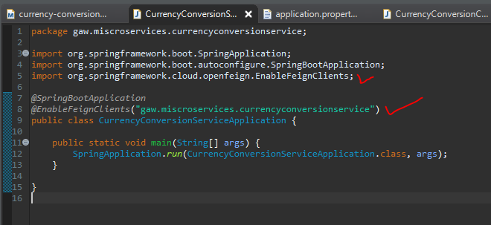

Create interface dengan method sama seperti class yang akan di-invoke, tapi beda return class nya aja

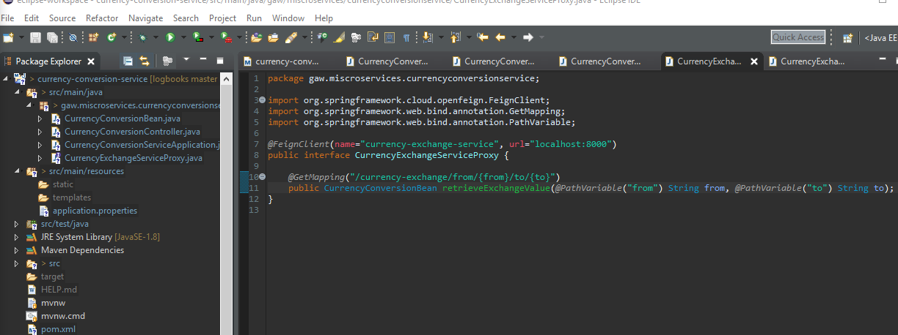

Lihat perbandingannya

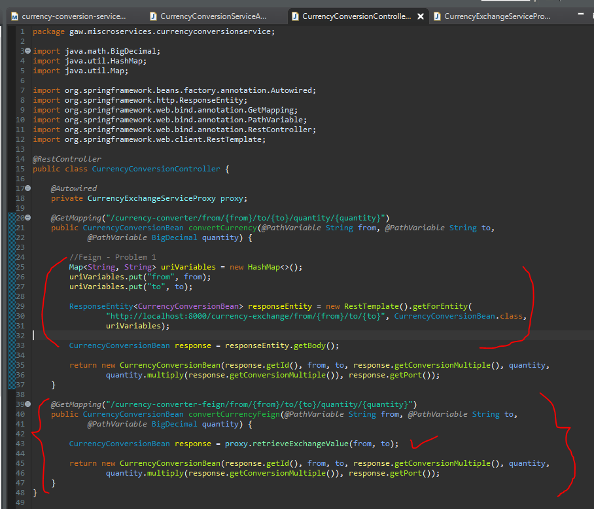

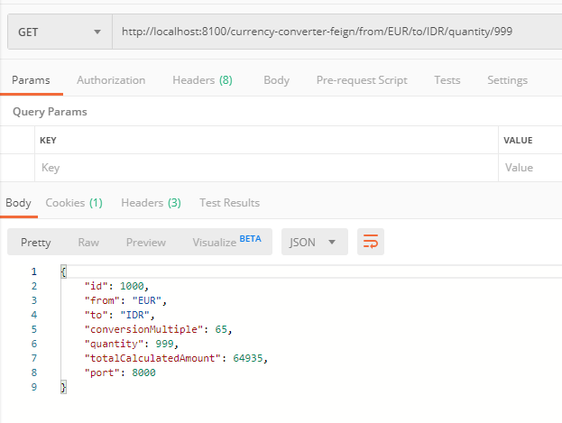

**Client side load balancing with Ribbon**

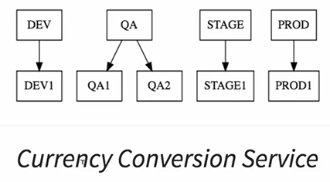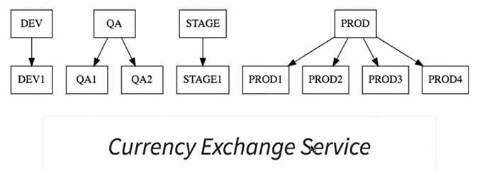

Ga mau kan hardcoded ini?

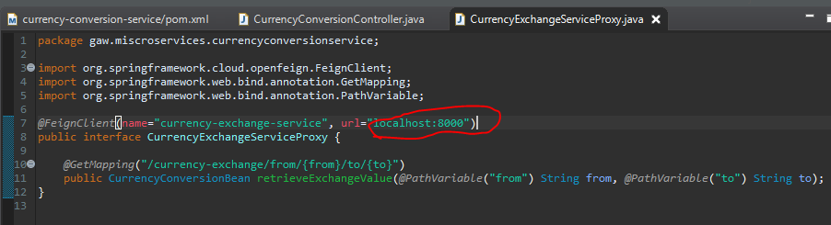

Makanya ada ini

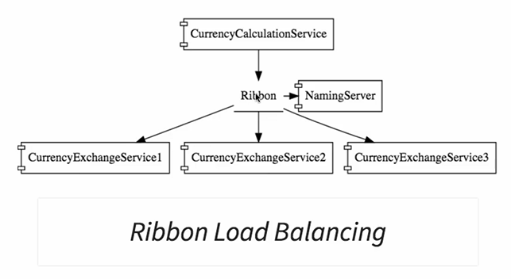

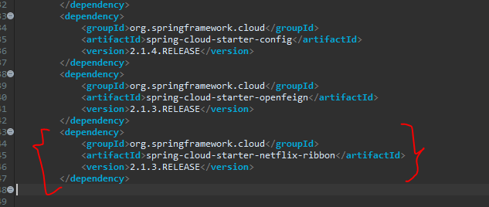

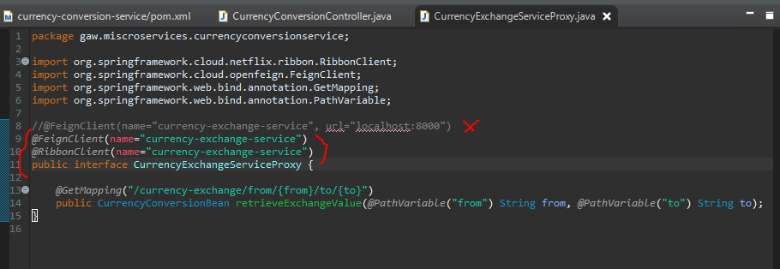

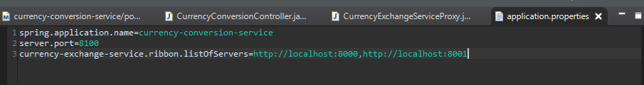

Execute currency exchange microservice 2 instance:  
>java -jar target\currency-exchange-service.jar (port: 8000 – default settingan application.properties)

> java -Dserver.port=8001 -jar target\currency-exchange-service.jar (port: 8001)

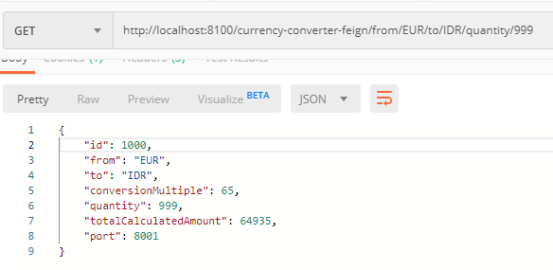 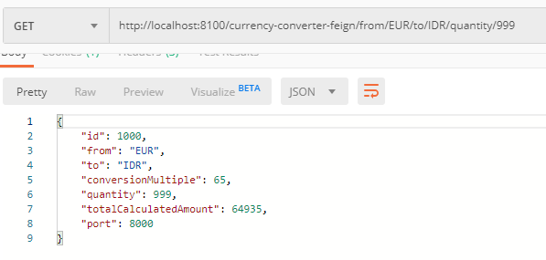

Problem: jika ingin nambah server atau nambah instance microservices, maka perlu nambah config di application.properties

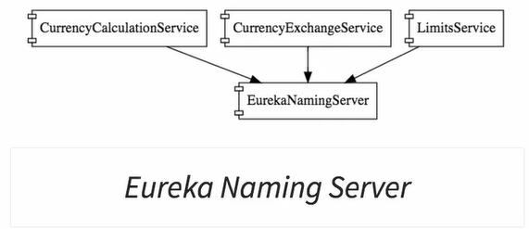

==============================================================================================

**Eureka Naming Server**

Create component for the Naming Server

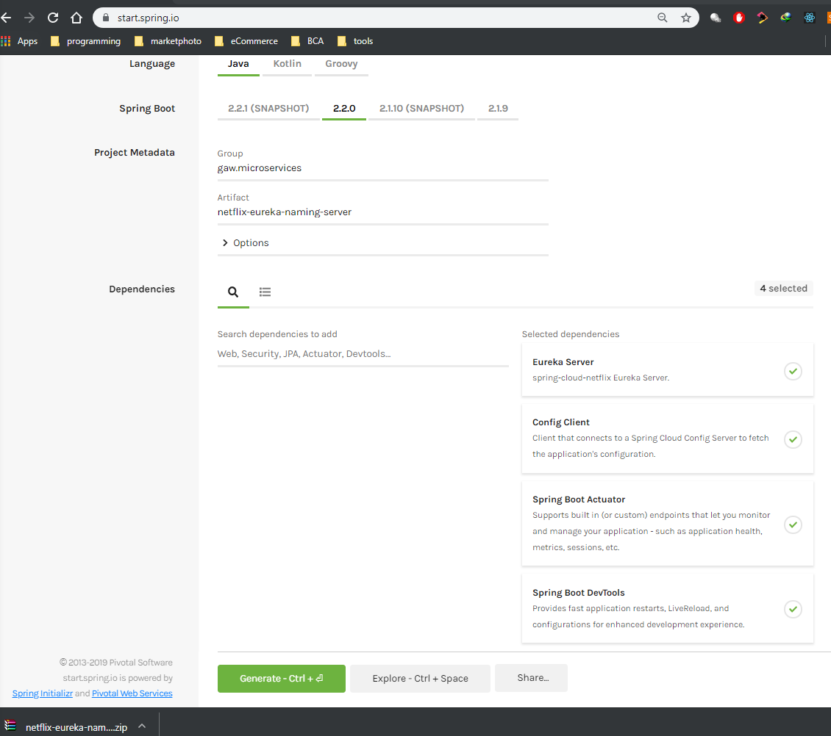

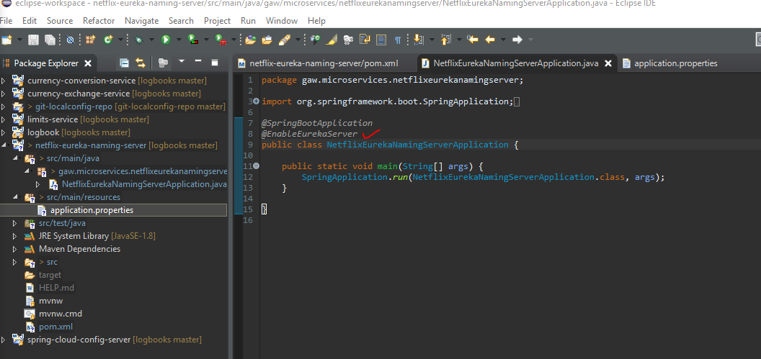

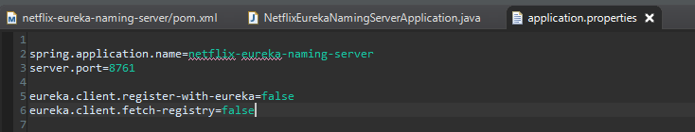

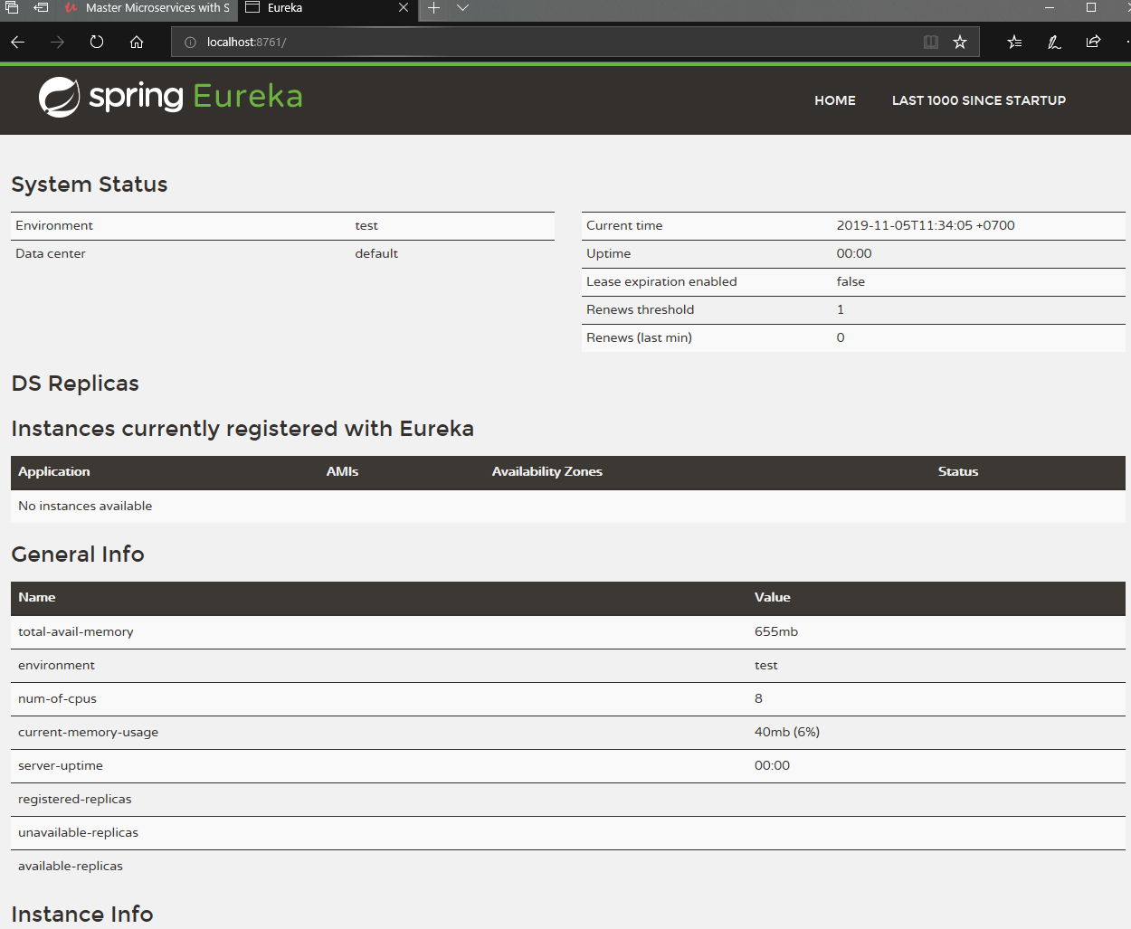

**Connecting Currency Conversion Microservice to Eureka**

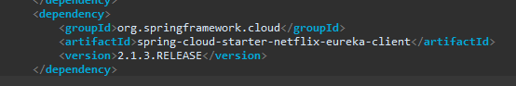

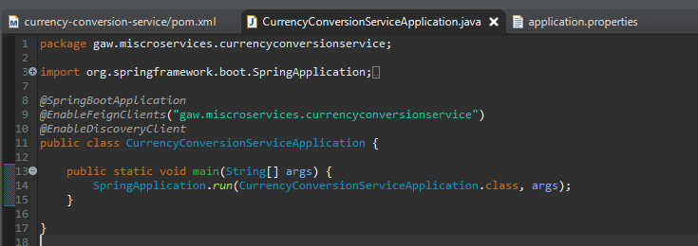

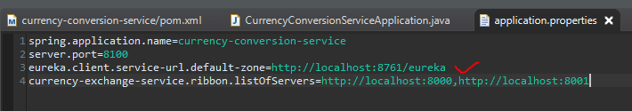

Pas compile Currency Conversion Microservice:

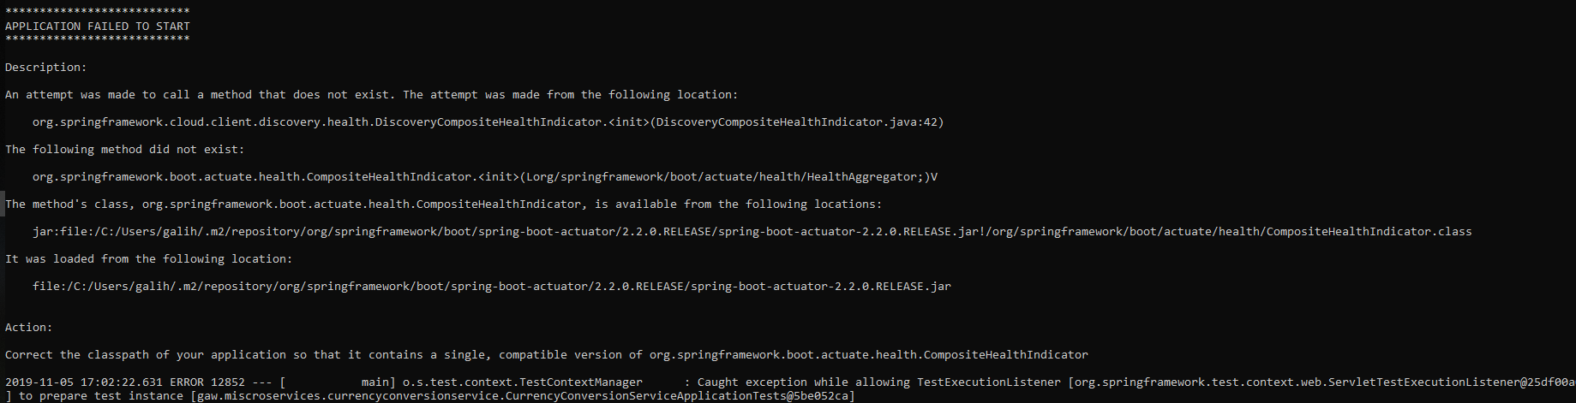

Solusi: enable lagi dependency managememt & repositories 🡪 balikin ke dafault

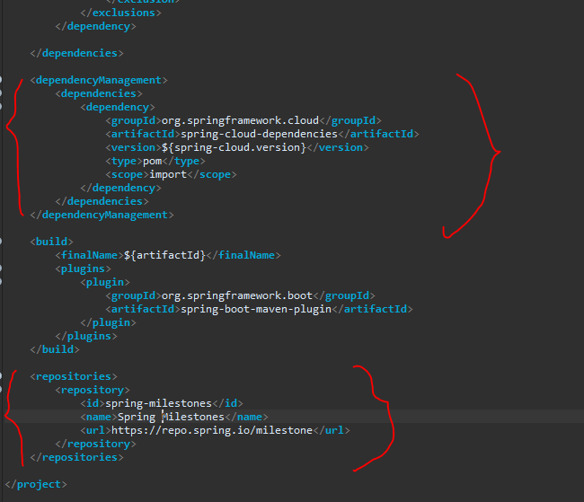

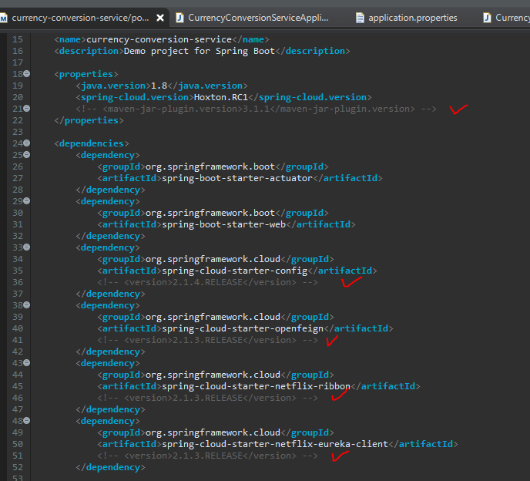

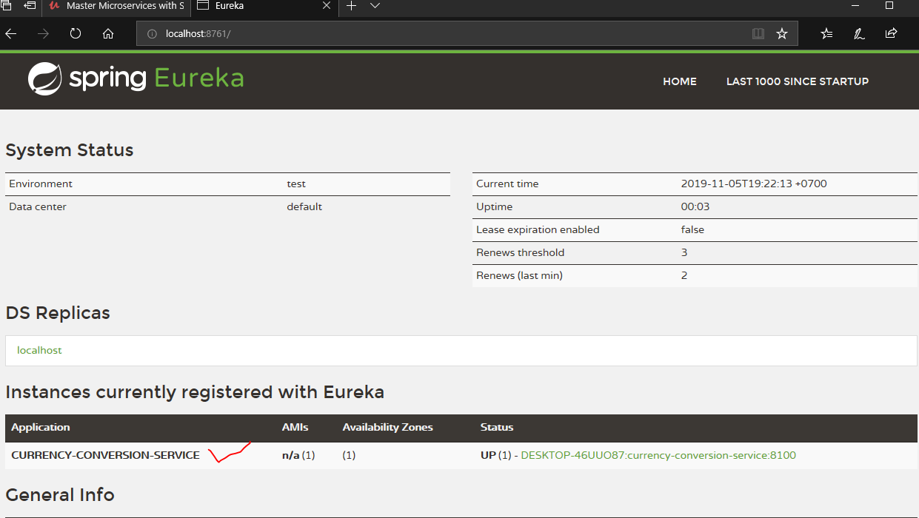

**Connecting Currency Exchange Microservice to Eureka**

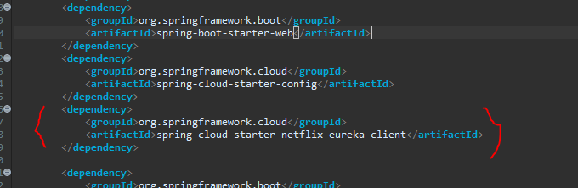

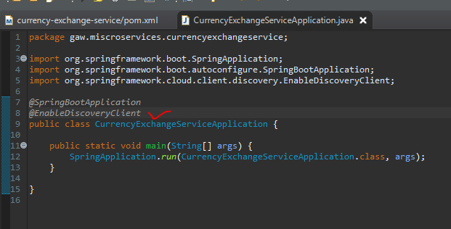

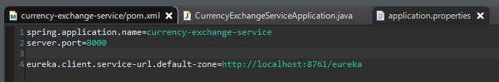

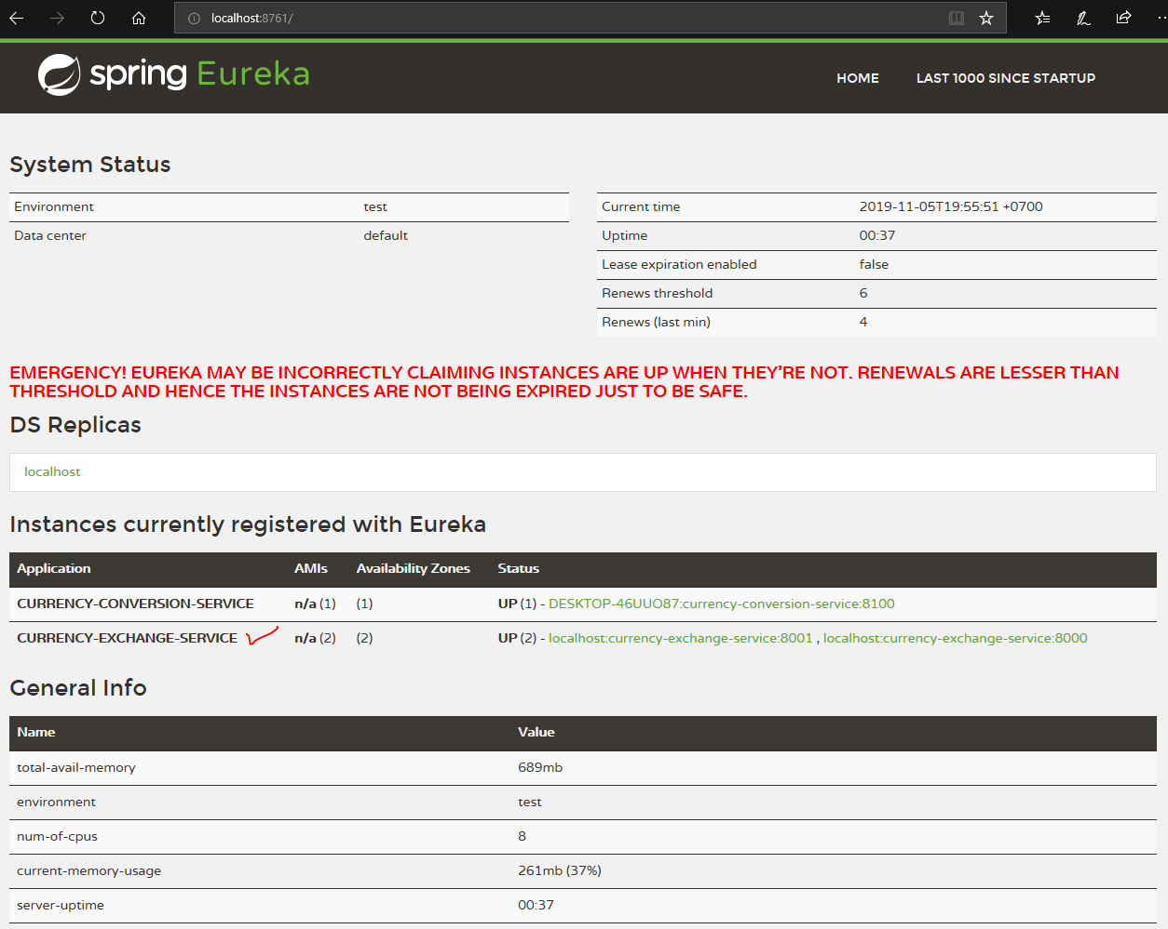

**Distributing calls using Eureka and Ribbon**

Disable aja listOfServer di CurrencyConversionService/application.properties

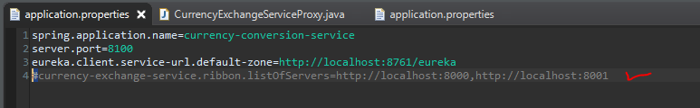

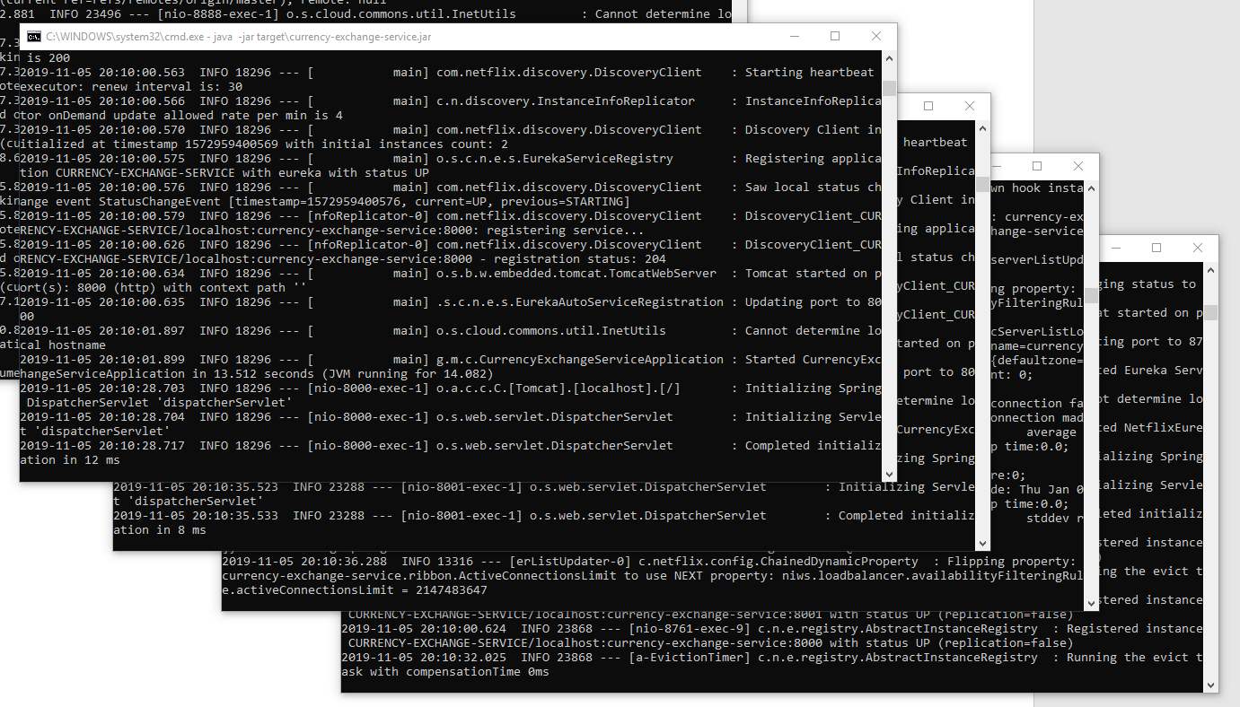

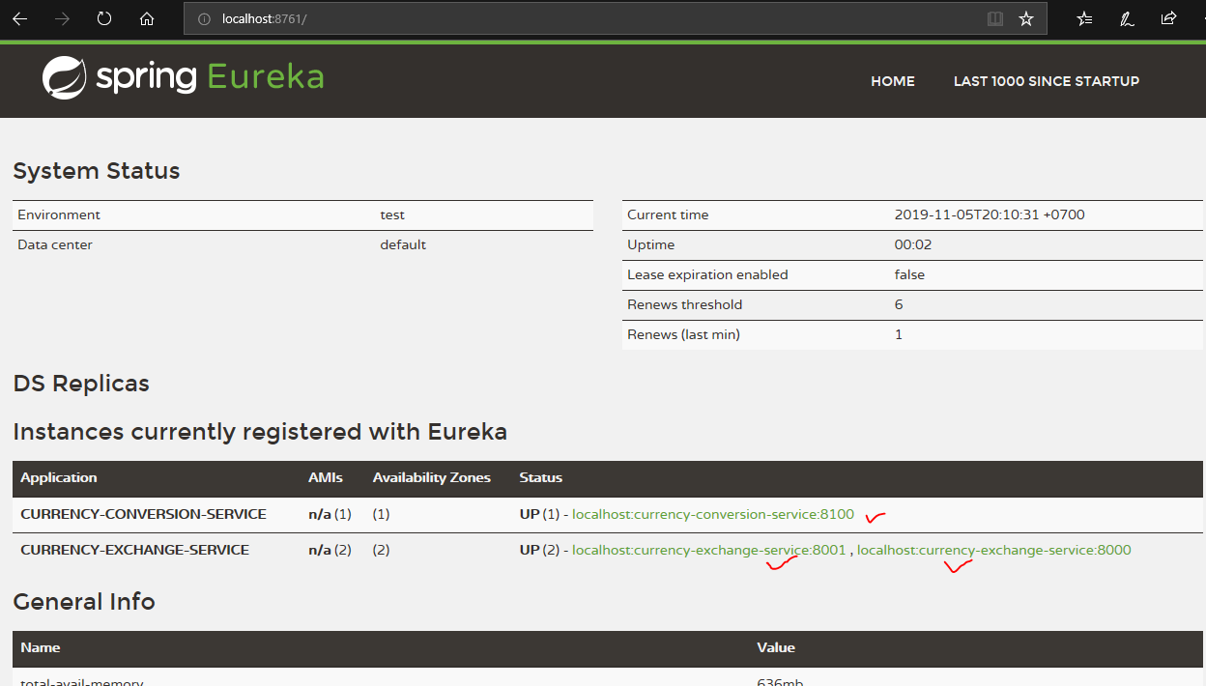

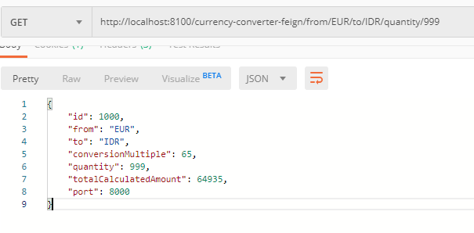 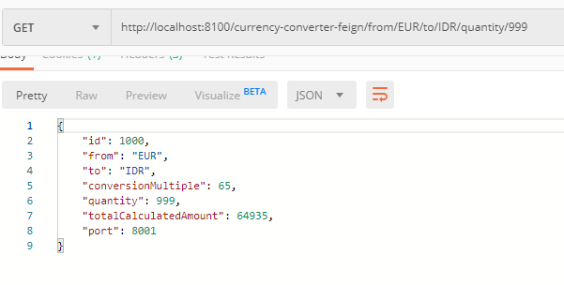

==============================================================================================

**API GATEWAY**

